4. a) Set up navigation between different screens using Navigator.

import 'package:flutter/material.dart';

void main() => runApp(const MyApp());

class MyApp extends StatelessWidget {
const MyApp({super.key});
@override
Widget build(BuildContext ctx) {
return MaterialApp(
title: 'Navigation Demo',
home: const FirstScreen(),
);
}
}

class FirstScreen extends StatelessWidget {
const FirstScreen({super.key});
@override
Widget build(BuildContext context) {
return Scaffold(
appBar: AppBar(title: const Text('First Screen')),
body: Center(
child: ElevatedButton(
child: const Text('Open Second Screen'),
onPressed: () {
Navigator.push(
context,
MaterialPageRoute(builder: (_) => const SecondScreen()),
);
},
),
),
);
}
}

class SecondScreen extends StatelessWidget {
const SecondScreen({super.key});
@override
Widget build(BuildContext context) {
return Scaffold(
appBar: AppBar(title: const Text('Second Screen')),
body: Center(
child: ElevatedButton(
child: const Text('Go Back'),
onPressed: () {
Navigator.pop(context);
},
),
),
);
}
}

OUTPUT
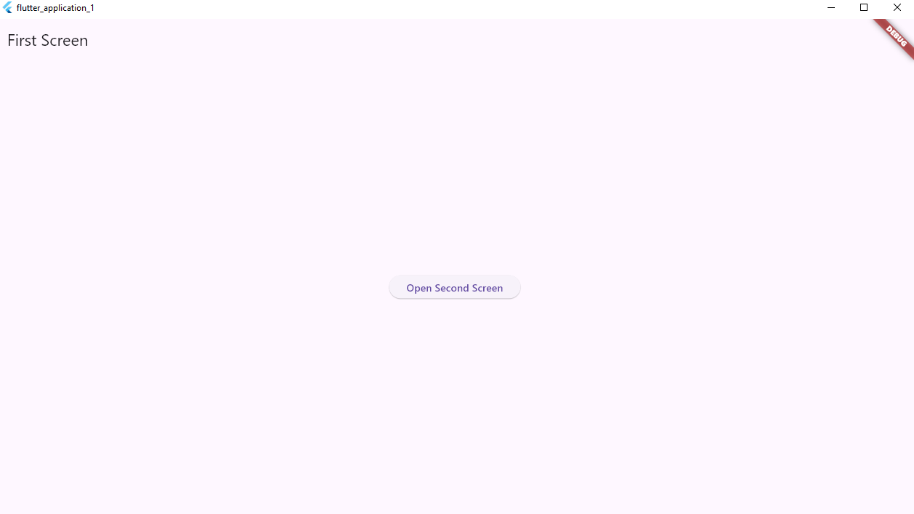
By clicking on open second screen button the below window will be displayed
